**Homework 11-Agile**

**Apps ideas:**

1.Online e-commerce website using a chatbot for products recommendations.

2.Party App is a mobile app and it looks like a combination between Google Maps(or Waze) and Instagram. Every user can publish their parties(public or private party) on the map and you can view their stories, bigger clips and accounts of other people that attended at a party.

3.A car simulator game on Android where you can make some missions, you can chose from 2 maps(city and countryside) and you can have real life cars. Eg: Ford Mustang with the same interior like in real life and the same exterior.

For this homework I will try to describe the second app because I think is the most interesting.

**Party App:**

**Party App description:** Our Party App must have maps of cities where the app is available, pretty much like Uber. At the beginning the app must start with one city where are a lot of parties like Bucharest.

Every map must contain users who can put their party location on the map. We are interested in teenagers parties first and after we can add more events like concerts or plays.

After that every user can select one public party and a window will open showing informations about the party like:

-party description eg: electronic music party/dresscode/dj etc

-user accounts who attend the party

-stories of users(this implies that every user must have an account)

-clips from the party

-friends who are at that party

-message people from that party

After 24 hours the party must be deleted automatically. Every user must have an account with parties. From that account she/he can add stories, message people from other parties, have a party point. The app must add points to the account after every party created or attended. After that every human can have a party status like: party pooper, party beast, the soul of the party etc.

We must have an admin account who can handle the accounts and finally we can add a 24 hour news. In this news feed we can videos from all the parties around the world.

**The first story:** A single user can view an empty map and can put a flag on a certain location.

As a user I want to add my party location.

Given the map online->the map has no content->I am the only one logged on the map->I can put a flag on the map

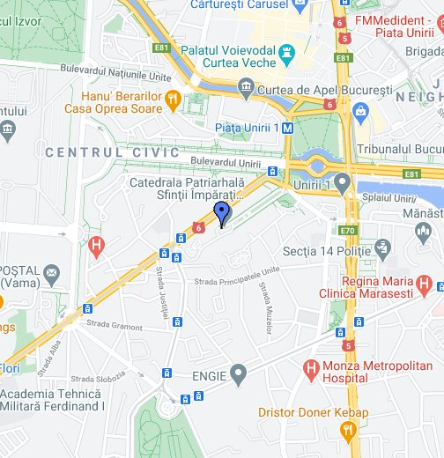

**Story 2:** Multiple users on the map who can add multiple flags.

The app must be capable of keeping multiple users with multiple locations.

The map is online->the map has no content->there are multiple users online->they can add multiple flags on the map

**Story 3:** Click on the flag and open a box

As a user I want to open a party and see the informations

Users online->clicks on the flag->the flag opens a window with informations about the party(eg: electronic music party/no-dresscode/alcohol available: whisky, tatra tea)

**Story 4:** Every user must have an user account for creating parties

As a user I want to create a party so I want an account.

User open the create account page->user create an empty account->from that account an user can create a parti

**Story 5:** An user can have friends online who watch his parties.

As a power user with account I want to be able to add friends

User search for a friend->add the human to his/her friend list->the other user must accept or decline

**Story 6:** An user can modify its own party description

As a power user I want to create my own party with my own description

User online->user put a flag on the map->user create its own party with its own description

**Story 7:** A party description must have an indication arrow.

As a user I want to go to that party so I want indications.

User online->opens party->go to indications->maps will provide indications

**Story 8:** Every party must have a story

As a power user I want to add a story to my party

User open edit party->add a photo/video in party description icon

**Story 9:** Every party can have videos/photos below description

As a power user I want to add videos/photos to my party

User online->user clicks on edit party->user adds videos/photos

**Story 10:** The party description must show the people who attend the party

As a normal user I want to see who is at the event.

User online->user opens party->user see all his/her friends and people who are at party

**Story 11:** All the people who attend the party can add photos/videos to the party description

As an user who attend at an event I want to add photos/videos to party description

User online->attend to a party->add videos to that party description

**Story 12:** The party story can be modified only by the owner

As a power user I want to be the only one who can add a new story to my party.

Power user online -> opens party edit -> add a photo/video in party story description icon

**Story 13:** The app must delete a party after 24 hours

The app must delete an event so as not to overload the map

App checks the party time->app delete the party after 24 hours

**Story 14:** Adding in the user account the possibility to speak with friends

As a power user I want to be able to speak with my friends

Power user online->power user open the messages->user can send messages to friends

**Story 15:** User can message the other users who attend one party

As a user I want to ask the other people about the party they are at

User opens a public party->user can see the description, the party story and all the activities in the party window->user can see all the people who participate at the event->user can ask the people about the event

**Story 16:** An administrator can handle the users

As an administrator I want to add or delete new users

Admin open the admin page->administrator search for an user->administrator modify the user

**Story 17:** A power user can change its own password

As a power user I want to be able to modify my password

Power user opens account option->user modify its password directly from the app

**Story 18:** A power user can delete the account

As a power user I need to be able to delete my account

Power user opens account options->power user delete the account

**Story 19:** Adding photos/videos from events into your account

As a power user I want to add photos in my profile from events

Power user edit account->user adds photos/video into account

**Story 20:** Adding a status to every user

The app must provide a status depending on the created events

Power user creates 20 parties -> user status update(from party pooper->party beast)

**Why I chose this order?**

I think that this order respects the agile principles. First the stories are simple and flexible. I started by creating a basic application from story 1, creating the first layer(map + flag on the map) and then started to add features from important ones to those that app may lack but are also important. Also the stories can be understood by non-technic clients.

The client can modify the stories, for example he can easily delete story 16 and choose to not have an administrator.

After creating the base app I choose to add the event description layer and to split it into multiple stories like adding description, adding people etc.

I also named the users who have an account power users and those who don’t have an account users and I split the creation account into another independent stories like deleting an account, adding videos etc.

In the end the client can choose to have the story 20 which says that every user can have a custom status, which I think is a very cool features to have but this won’t change the functionality of the app.